1. Design a html form of your choice to illustrate different input form controls to collect data from a user. I.e. Single and multiline text fields, dropdown box, radio buttons, checkbox, selectbox, submit and reset buttons

<html>

<head>

<title>inputControls</title>

</head>

<body>

<form action="" style="margin: 10px; padding: 10px;">

<label for="Name"

>Name:<input type="text" name="Name" size="30" />

</label>

<br />

<br />

<label for="ProfilePic"

>Profile Picture:

<input type="file" name="ProfilePic" accept="image/\*" />

</label>

<br />

<br />

<label for="userId" style="padding-right: 10px;">

UserId: <input type="text" name="userId" />

</label>

<label for="password">

Password: <input type="password" name="password" />

</label>

<br /><br />

<label for="Address"

>Address: <textarea name="Address" id="" cols="30" rows="5"></textarea>

</label>

<br />

<br />

<h3>Hobbies</h3>

<label for="Hobbies" style="padding: 10px;"

><input type="checkbox" />Reading</label

>

<label for="Hobbies" style="padding: 10px;"

><input type="checkbox" />drawing illustrations</label

>

<label for="Hobbies" style="padding: 10px;"

><input type="checkbox" />Playing instruments</label

>

<label for="Hobbies" style="padding: 10px;"

><input type="checkbox" />Travelling</label

>

<br />

<h3>Gender</h3>

<label for="Gender" style="padding: 10px;"

><input type="radio" name="Gender" value="Male" />male</label

>

<label for="Gender" style="padding: 10px;"

><input type="radio" name="Gender" value="Female" />Female</label

>

<br />

<br />

<label for="Profession">

<span>Profession: </span>

<select name="Profession" id="prof">

<option value="Student">Student</option>

<option value="Worker">Worker</option>

<option value="Business Owner">Business Owner</option>

</select>

</label>

<br />

<br />

<br />

<input type="submit" name="submit" value="Submit" />

<input type="reset" name="reset" value="Reset" />

</form>

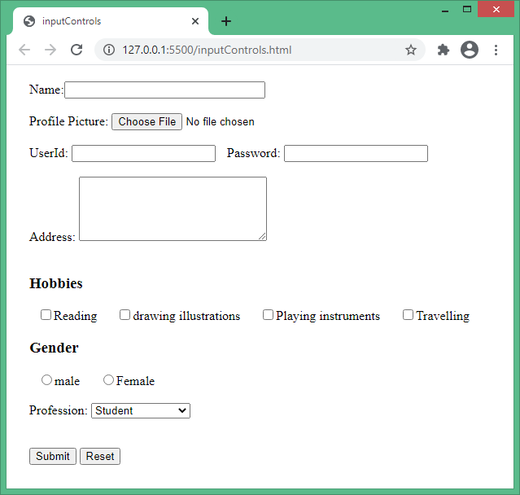 </body>

</html>

2. Using html form tags design, a railway reservation form.

<html>

<head>

<title>railway reservation form </title>

</head>

<body>

<form name="railway">

<h1> Railway Reservation form </h1>

<table>

<tr>

<td>From:</td>

<td><input type="text" name="railway"></td>

</tr>

<tr>

<td>To:</td>

<td><input type="text" name="txt2"></td>

</tr>

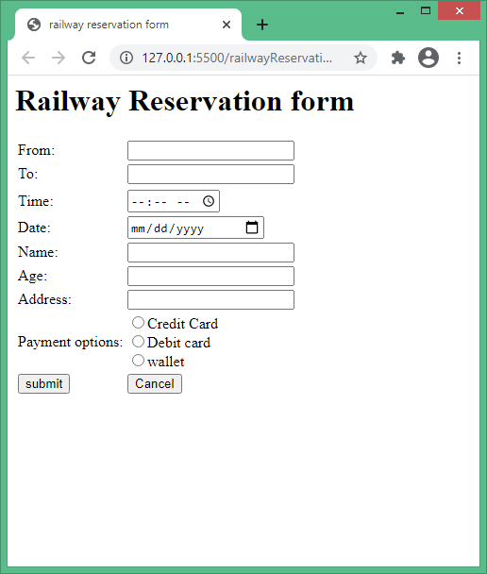 <tr>

<tr>

<td>Time:</td>

<td><input type="time" name="time"></td>

</tr>

<tr>

<td>Date:</td>

<td><input type="date" name="date"></td>

</tr>

<td>Name:</td>

<td><input type="text" name=""></td></tr>

<tr>

<td>Age:</td>

<td><input type="number" name=""></td>

</tr>

<tr>

<td>Address:</td>

<td><input type="text" nqme=""></td></tr>

<tr>

<td>Payment options:</td>

<td>

<input type="radio" name="payment" value="cc" />Credit Card <br />

<input type="radio" name="payment" value="dc" />Debit card <br />

<input type="radio" name="payment" value="wallet">wallet<br/>

</td> <tr>

<td><input type="submit" value="submit"></td>

<td><input type="submit" value="Cancel"></td></tr>

</table>

</body></html>